**Work flow for 499B**

In our project we have two microcontrollers, one is Arduino UNO and another one is Raspberry Pi. First, we will integrate all sensors with Arduino Uno and do code in Arduino IDE and will check whether all the sensors giving data properly or not. Here a pi camera will be installed in Raspbian Pi. Also, there will be a serial communication between Arduino UNO and Raspberry-pi so that all the data from Arduino can be received by raspberry pi. There will be an internal connection between these two microcontrollers. Arduino’s transmitter will be connected to raspberry’s receiver and raspberry’s transmitter will connected to Arduino’s receiver. In this way they will be internally connected. We are using pi cam for seeing air transparency and also for structural count & sensors are for pollutants detection. After receiving data from Arduino, raspberry pi will send its information to server. For this we need internet connection. In this stage we will use a pocket router with 4G sim which will create a Wi-Fi hotspot and raspberry pi will be connected to this hotspot and will be able to send its data to server. Now all the data will cast to server and then we will read these data from a desktop client. It will work as user interface; we can choose an application or choose website to read this data. Primarily we have thought to view the preliminary streaming data.

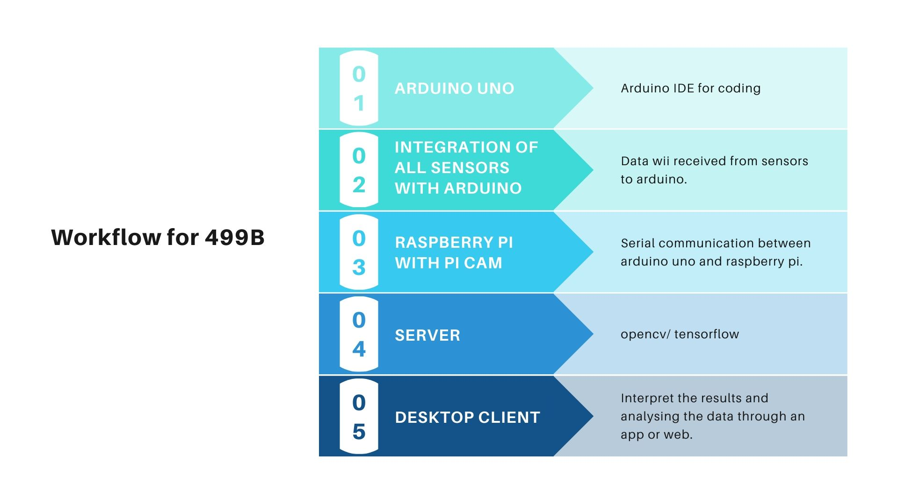

Fig 1: Flow chart for 499B.